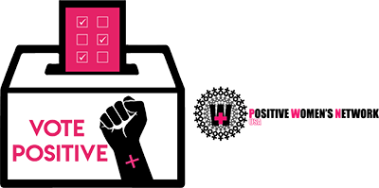
DEBATE NIGHT BINGO!
Family Separation | Cash Bail | Public Charge | LGBTQ | Voting Rights
Gender Non-Conforming | Housing is Healthcare | The South | People with disabilities  or  Disability Rights | Affordable Care Act
Human Rights | Abortion | FREE SPACE | Mass incarceration | Title X
Climate Change  or  Climate Crisis | Medicare For All | Paid Family Leave | HIV/AIDS | Sex Work
Black Women | People of trans experience  or  Transgender people | Liberation | Medicaid | Decriminalize

